CDA 3201L - Thursday (3:30 - 4:45PM) Section 005

Lab #01 - Combinational Logic Circuits (1)

9/10/2016 - Steven Romeiro, Jennyfer Munoz

**Purpose & Objectives:**

To show how the theoretical applications of combinational circuit logic can be directly demonstrated with the usage of proper Integrated Circuits (IC), LED’s, a 5v Power Supply and a Breadboard. Part A of the lab requires the simplification of a Boolean expression using the Laws of Boolean algebra, and implement the resulting circuit using inverters, 2-input AND gates, and 2-input OR gates. Part B asks to verify that the NOR operation is functionally complete using Laws of Boolean algebra. Implement the functions NOT, AND and OR using only 2-input NOR gates.

**Components Used:**

|  |  |  |
| --- | --- | --- |
| **Name** | **Type** | **Quantity** |
| 74LS08 | AND IC | 1 |
| 74LS32 | OR IC | 1 |
| 74LS04 | Inverter IC | 1 |
| 74LS02 | NOR IC | 2 |
| 470 Ω Resistor | Resistor | 4 |
| LED | Red LED | 4 |
| Power Supply | 5v | 1 |
| Wire Kit | Assorted | 1 |

**Description:**

**Part A Simplilfication:**

Z = Y’ + (W’U + WU) + U’Y

Z = Y’U (W’ + W) + U’Y

Z = Y’U + U’Y

Z = Y ⊕ U

**Truth Tables:**

**XOR**

|  |  |  |
| --- | --- | --- |
| X | **Y** | **Y’U + YU’** |
| 0 | 0 | 0 |
| 0 | 1 | 1 |
| 1 | 0 | 1 |
| 1 | 1 | 0 |

**Part B:** Implementation of the following gates using only NOR gates. See Diagram.

**NOT**

|  |  |
| --- | --- |
| **X** | **X’** |
| 0 | 1 |
| 1 | 0 |

**AND**

|  |  |  |  |
| --- | --- | --- | --- |
| **X** | **Y** | **(X’ + Y’)** | **(X’ + Y’)’** |
| 0 | 0 | 1 | 0 |
| 0 | 1 | 1 | 0 |
| 1 | 0 | 1 | 0 |
| 1 | 1 | 0 | 1 |

**OR**

|  |  |  |  |
| --- | --- | --- | --- |
| **X** | **Y** | **(X + Y)’** | **[ (X + Y)’ + (X + Y)’ ]** |
| 0 | 0 | 1 | 0 |
| 0 | 1 | 0 | 1 |
| 1 | 0 | 0 | 1 |
| 1 | 1 | 0 | 1 |

**Diagram:**

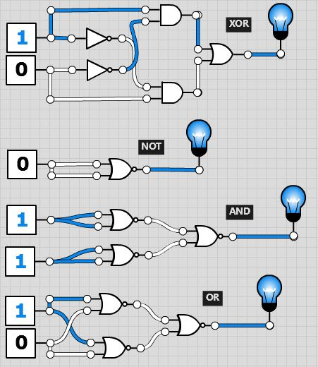

**Discussion & Conclusion:**

Our designs allowed us to completely eliminate an input from Part A via simplification. After theoretically simplifying the expression to it’s simplest terms, we were able to verify the results by implementing the system with Integrated Circuits and a Breadboard. In Part B we were able to successfully build AND, OR and NOT gates using simply a few NOR gates. The logic proved feasible on paper until implementation phase. A few difficulties were encountered during implementation that included properly tracking which NOR gate outputs were inputs to subsequent NOR gates in the chain. But once overcome, this implementation proved a success. The ability to simplify a system using fewer IC’s not only eliminated an unnecessary input, it also reduces production costs by using fewer gates. In contrast, the universality of the NOR gate allows one to construct any logic sequence at the cost of additional chips.